Project Design phase-1 Solution Architecture

|  |  |
| --- | --- |
| Date | 21 October 2022 |
| Team ID | PNT2022TMID34986 |
| Project Name | Intelligent Vehicle Damage Assessment and Cost Estimator for Insurance Companies |
| Maximum Marks | 4 |

Solution Architecture Diagram:

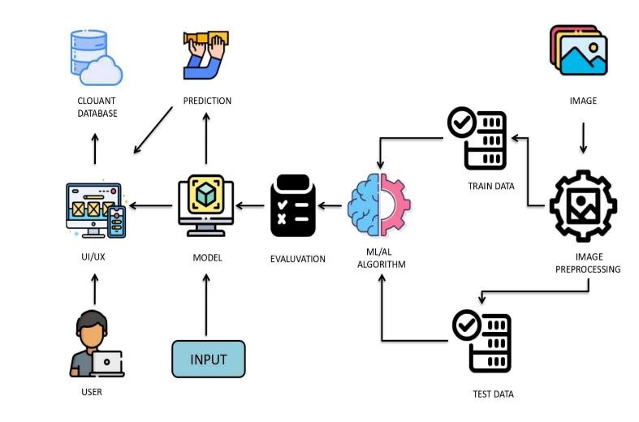

Technologies used for Intelligent Vehicle Damage Assessment and Cost Estimator for Insurance Companies:

* Working with Image processing technique
* Working in Trained CNN model
* Working in Deep Learning
* Using Python Programming
* Build web application using Python Flask

Platform

* Git & GitHub - Project Management
* IBM Cloud - Hosting
* IBM Watson - Training the Deep Learning Model

